**SCENARIO**

**About the organization:**

ACN Software Solutions is an e-commerce startup, which recently got VC funding. They earlier had only 5 employees, however, they have now shifted to a new facility and have expanded their workforce, with 4 different departments: Finance, HR, Marketing and Software development, each on 1st,2nd, 3rd and 4th floor of their facility.

**Requirements:**

The ground floor is for servicing the walk-in customers, who have access to internet through Wi-Fi, with some constraints:

1. They can access internet only on smartphones
2. They cannot access any social media sites.
3. Suggested to provide 2 computers for customers to find more information about the organization.

The company has provided the following requirements with respect to network access between departments:

1. Finance department can access data of any other department, but no department can access data of finance department.
2. HR dept. can access Marketing and Software development depts.
3. Marketing and Software development departments can communicate to each other over network and access each other’s data.

The company has the following other expectations from the network:

1. Adequate security for all of the company communications and documents (especially sensitive sales documents)
2. Fast and have additional capacity as the company grows
3. Provides for 3 9’s availability
4. Provides for long-term cost effectiveness

The company has specifically mentioned the following devices and software:

1. Printers on each floor: the company wants centralized printing on every floor
2. 2 computers in the ground floor for walk-in customers to use
3. Suite of software tools for the employees to effectively communicate. Google search, office 365, outlook for email

INITIAL NETWORK MAP

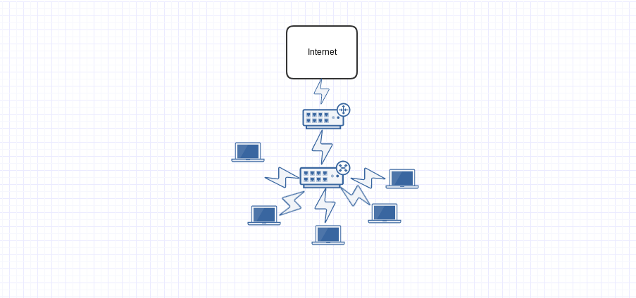

**Network management:**

Provide for centralized management and control of the network & devices, so that network can be maintained from remote location.

**E-commerce website:**

Provide customers with a general information Website and a secure Website where clients can buy services, and products

**Assumptions:**

1. We assume there are 2 employees in ground floor. We also assume they have one central printer.
2. The ground floor customer service dept. does not have network access to any other dept.

All communication with higher department happens through phone, for ensuring cost effectiveness.

1. Location of facility:
   1. We assume that the facility is in a location where ISPs which provide high speed WAN connections are present. This means that there will be no need to consider satellite connections to WAN.
2. Infrastructure:
   1. Every floor has separate rooms where web and data servers can be placed.
   2. Sufficient cooling apparatus, such as air conditioning, has been installed for maintaining appropriate temperatures for server room.
   3. Wiring conduits for carrying power cables and ethernet cables are built.
   4. There is sufficient power availability, with rare and small power cuts. We also assume they have set up back-up electricity storage for handling power cuts.
   5. We assume that they have a warehouse facility which is connected to the WAN. We also assume that the inventory is regularly updated for the e-commerce application. The warehouse must have restricted access to the cloud application to do the same.

**SCOPE**

**DO’s**

* Minimizing the cost while keeping customer needs
* Scrapping the previous topology
* Creating new topology to meet customer specifications
* Delivering within – 3-4 weeks
* Blocking social media for walk in customers
* Making sure walk in customers can only use their mobile devices/smartphones
* Making sure walk-in customers have only wifi access
* Implement access control to take care of who can access which data
* Will provide the list of necessary hardware
* Access control should also take care of hierarchy of users i.e privilege based on group they fit in.
* Providing internet access to all users (mostly all will need it)
* For in prem – different kind of security measures security
* From the cloud to in-prem – different kind of security should be maintained
* ISP will take care of bandwidth that is necessary
* Centralized printing per floor
* Simple redundancy for in house data (maybe one more backup)
* Employees will get a set of software tools (as specified in the document)
* Central management control
* Getting a DMZ in place between the in-prem and cloud

**DONT’s**

* Not restricting access of websites that employees browse
* No redundancy for website for on-prem
  + Cloud takes care of it
* We don’t take responsibility for the security/ any malicious intent from existing employees

**Technical and Business goals**

**Client’s elevator pitch:**

Designing network which is suitable for current expansion of the organisation which leads to increase in revenue and profit.

**Business Goals:**

* Increase revenue and profit
* Increase employer productivity
* Offer better customer service
* Avoid business disruption caused by network security problems
* Better support for mobile users
* Long term cost effectiveness
* Centralised management
* Staffing constraint

**Technical Goals:**

* Wireless solution support
* Scalability
* Access control policies across the department
* Security
* Availability
* Service provider (WAN)
* Adaptability
* Remote manageability

**Constraints for achieving the above business and technical goals:**

* Since before the expansion there were only 5 employees and they had a flat network we need to build a new network architecture for the company.
* As company depicted in the design scenario is an e-commerce company security becomes very important.
* As new employees are being recruited, educating them about the organization's network requirements is also very important when we consider network management point of view.

**Network Design trade-off chart**

* Scalability 15
* Availability 15
* Security 15
* Manageability 10
* Usability 10
* Adaptability 10
* Affordability 10
* Network Performance 15

**Logical Design**

**Proposal:**

* Overview

Implemented a hierarchical architecture

Core layer, distribution layer and access layer are included

* Enterprise WAN backbone

This comprises of the cloud

* DMZ

The area between two firewalls

The centralized management server is located here

* Centralized Management Server
* Distribution Layer

Directs the access between the 5 different access layer groups

* Pre-installed software suites

The software required by the company such as Office 365, Outlook etc. would be installed on the servers on each floor, so that every department can access their suite of software separately, hence leading to less congestion on the network. Another option is to maintain different servers for hosting software, thus keeping it isolated from the core network.

* Access Layer

Finance

HR

Marketing

S/W

Customer

QoS Parameters

* Throughput
* Transit Delay
* Minimum bandwidth
* Drop Rate
* Successful data transfer upload and download

**P.T.O**

**Network Map:**

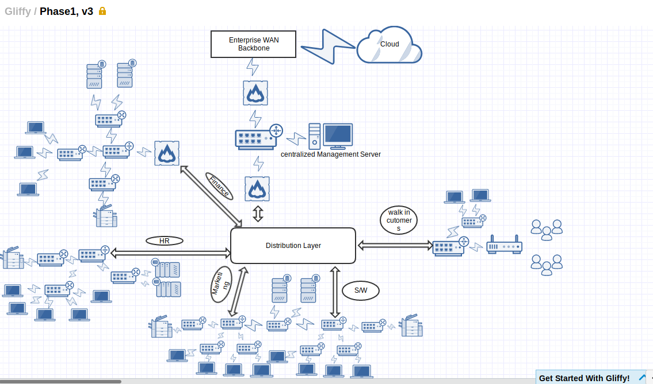

**Cost Estimates**

***Hardware devices required and associated costs*:**

**Core Layer**

The core layer is responsible for fast and reliable transportation of data across a network. The core layer is often known as the backbone or foundation network because all other layers rely upon it. Its purpose is to reduce the latency time in the delivery of packets.  
At the core layer, efficiency is the key term. Fewer and faster systems create a more efficient backbone. There are various equipments available for the core layer.

|  |  |
| --- | --- |
| **DEVICE** | **COST** |
| Cisco switch 7000 series (for WAN) | Rs. 9,47,000/- |
| Catalyst 6000 series (for LAN) | Rs. 2,80,000/- |
| T1 lines | Rs. 14,000/- per month |
| Cisco ASR 1000 series switches | Contact Cisco for quote |
| Cisco ISR-4221 business routers | Approx Rs. 50,000/- |

**Distribution layer**

The distribution layer is responsible for routing. It provides policy-based network connectivity including Firewalling, QoS, etc. The devices in this layer would be:

|  |  |
| --- | --- |
| **DEVICE** | **COST** |
| Cisco 24 Port Gigabit Switch (10/100/1000) | Rs. 7,000/- |
| Cisco ISR-4221 business routers | Approx Rs. 50,000/- |

**Access layer**

|  |  |
| --- | --- |
| **DEVICE** | **COST** |
| Cisco 24 Port Gigabit Switch (10/100/1000) | Rs. 7,000/- |
| Cisco ISR-1000 series routers | Contact Cisco for quote |
| Cisco ISR-800 series routers | Contact Cisco for quote |

***Estimate of cloud costs for 3 years***

CLOUD COSTS(ONLY CLOUD AND WAN)

|  |  |  |  |
| --- | --- | --- | --- |
| Category | Year 1 costs | Year 2 costs | Year 3 costs |
| Hardware | - | - | - |
| Setup costs | 3,50,000 | - | - |
| Software (Licensing) | - | - | - |
| Labour costs | - | - | - |
| Service costs | 10,00,000 | 25,00,000 | 40,00,000 |
| WAN costs | 500,000 | 7,50,000 | 12,00,000 |
| Cost for a year | 18,50,000 | 32,00,000 | 52,00,000 |

DEVICE COSTS

|  |  |  |  |
| --- | --- | --- | --- |
| Item | Cost Per item | No of items | TotalCost |
| ASA5545-FPWR-K9 Firewall | 10,104$ | 1 | 700000rs |
| ASA5508-K9 Firewall | 1,132$ | 2 | 158480rs |
| Core Layer Cisco Catalyst 6513-E | 22000$ | 1 | 1540000rs |
| Distribution Router | 65000rs | 1 | 65000rs |
| 1000ft fiber optic | 5870$ |  | 410000 |
| Dell 1.7 Ghz Tower Server Processor E5­2609v4 T430 | 1,20,000rs | 1 | 120000 |
| Epson L565 Printer | 17000rs | 4 | 68000 |
| Cisco 24 post gigabit switch | 7000rs | 14 | 98000 |
| Access layer router | 15000rs | 3 | 45000rs |
| Wireless Router | 25000rs | 1 | 25000rs |
|  |  |  | 28,60,480 |

Approx cost : 30lakh excluding WAN and Cloud Costs

Notes:

1. All costs mentioned above are rough estimates, and may or may not reflect the actual cost to be incurred by the company.
2. Software licensing costs indicated do not consider software suits to be used in company’s internal network.
3. Labour costs indicated refer to labour for hardware and server maintenance. It does not include costs for software engineers.
4. The year-on-year increase in service costs and WAN costs have been proposed according to the company’s scalability goals over the coming years.
5. Setup costs indicated refer to any costs incurred by the company for initial setup of cloud infrastructure, associated planning costs, shifting of existing data from private servers to cloud, etc.